Maths | Geography | English
Written Work  Continue learning about fractions this week! Use the Powerpoints to help you solve problems on the sheets.  Doodle Maths  Remember to login to Doodle Maths every day and also use your Doodle Tables.  Hit the Button  Hit the Button is a great website to use to practise your times tables and you can challenge someone in your house to a game!  Activity Mat  Try the Maths Activity Mat to keep your maths knowledge up to date!  Maths Meeting  Try the Maths Meeting – the slides have been sent to you.  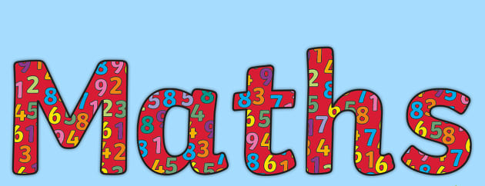 | Continuing with Geography this week we are learning to compare maps with aerial photographs.  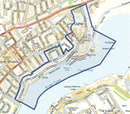  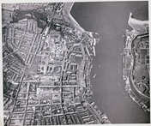  Can you identify landmarks on the aerial maps and find them on the map? | Monday - Pobble 365 – Afterwards  Tuesday - First News - Crossword  Wednesday - Purple Mash - Login and complete this week's Grammar activities. Spellings - Five spellings to practice, practice, practice…  Thursday - WORLD BOOK DAY  Enjoy listening to Friend or Foe by Michael Morpurgo  https://www.bbc.co.uk/teach/school-radio/english-ks2-friend-or-foe-michael-morpurgo-index/znb78xs  Thursday - Letters from the Lighthouse by Emma Carroll. After watching the video of Mrs Marshall reading Chapter 9 – Attack on all fronts  Friday - Letters from the Lighthouse by Emma Carroll. After watching the video of Mrs Bourne reading Chapter 10 – Careless talk costs lives  Reading Plus - We are keeping a close eye on your usage so remember to log in every day and check for any messages!  Site code - rpnewyo1
Science | Year 5 Home Learning  World War 2  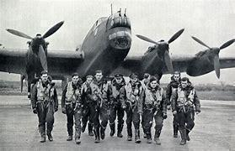  SPRING TERM 2 Week 2  Remember: Logon to Doodle Maths, Reading Plus, Accelerated Reader and Purple Mash | PSHE
Use your science time this week to design your Lab Coat for our exciting school competition. The theme is ‘What science means to you’.  The more colourful and eye-catching – the better!  Think about what science means to you in school and in the world around you.  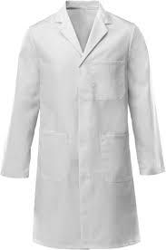 |  | This half term, we are looking at the importance of healthy eating. This week we are looking at the traffic sign system using on food labels.  Have a look around your kitchen for different food labels and record what you find!  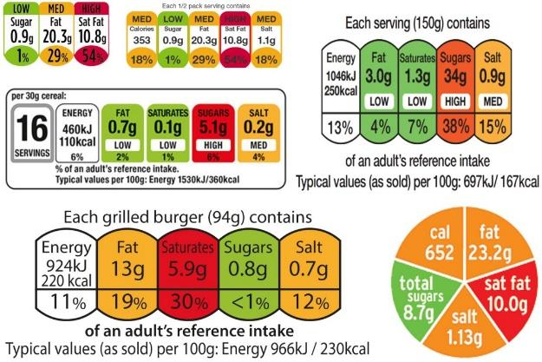
Design Technology | French | PE
Make Do and Mend  'Make do and mend' was an initiative from WW2 when resources were scarce and women reused old clothing. What else can you find out about it?  Next week in DT we will learn a range of stitches so that we can make hand puppets - just like the ones in Letters from the Lighthouse. Have a look at the stitches we will be trying | In French, we have been learning about different food and drink this half term. We are learning more names for French food. This week, you are going to write a party invitation – in French! Think about the food and drinks that you will eat at the party and use the template that has been sent to help you!  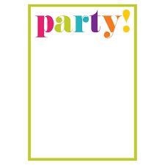 | Continue to keep active using the booklet of home PE ideas that we have sent for you. These will be fun for all the family and can be done using things around the home. We would love to see some photographs of any that you try out!  Can you create your own active games using things around the house?  As always - try and do your daily mile! 20 minutes of walking or jogging - or even running on the spot!

