REMOTE LEARNING 2020/21 – Year 3 Week 7

The timetable below is provided to ensure that your child can continue to access learning whilst absent from school. Your child’s teacher will provide the learning to be completed in the allocated slots on the timetable. If your child is unwell, there is no expectation that they complete the activities on this timetable but would do what they can when you feel they are well enough. These continue to be unprecedented times and we must work together to ensure that children's learning continues to progress. As during lockdown, teachers will remain in touch and will respond to any queries you may have. This timetable and accompanied learning is not meant to burden you at home but to provide clarity of what your child is expected to do when unable to access school. Thank you for your support, keep following us on Twitter and together we will continue to make this work.

 | 9.00 - 9.30 | 9.30 - 10.30 | 10.30-11.30 | 11.30 - 12.30 | 12.30-1.30 | 1.30 - 2.30 | 2.30-3.30
Monday | RWI – Phonics/  Reading | English | 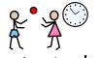  Break Time | 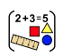  Maths | Dinner Time | Geography (Mrs Potter) | PSHE
Tuesday | RWI – Phonics/  Reading | English | Break Time | Maths | Dinner Time | Geography | Art
Wednesday | RWI – Phonics/  Reading | Maths | Break Time | 11.00 LIVE LESSON Kahoot (Miss Fergus) | Dinner Time | Geography | Science
Thursday | RWI – Phonics/  Reading | Maths | Break Time | English | Dinner Time | Geography | RE
Friday | RWI – Phonics/ Reading | ICT | Break Time | English (Mrs Davidson) | Dinner Time | Geography | Purple Mash
Daily Learning tasks – Monday 22.02.21

Subject | Learning objective | Activity
Miss Burn | L.O. To be able to predict what might happen  from details stated and implied.  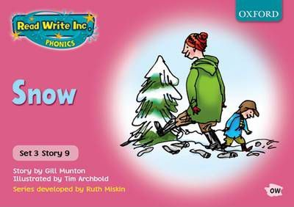 | Phonics - Watch the videos of Miss Burn and complete your speed sounds and green words. Then complete your daily phonics activity. Today is the first day of our new sound - ‘e.’ I would like you to write the date in your RED book and then practise your handwriting by writing 2 lines of your new sound ‘e’.  Prediction  Today we are starting a new book. Our new book is called ‘Snow’.  Day 1 of a new book is prediction day.  Have a look at the front cover. Does this give you any clues about the book?  Have a look at this week’s words to clarify.  Read the book introduction.  Then make your prediction :  Its wonderful waking up in the morning when everything is white! It makes you want to run outside and play in the snow. Let me tell you about when I was little… When it snowed in the night, I would look out of my window in the morning and see a soft, bright sheet covering the street. I would jump out of bed, throw on my fleece and wellingtons, pull on my hat and gloves, and then venture out into the street to play...  What do you predict the children will do in the snow?  Write the learning objective into your RED book and make your prediction using the sentence starter:  I predict that the children will ______________ and __________________ in the snow.
Miss Fergus | 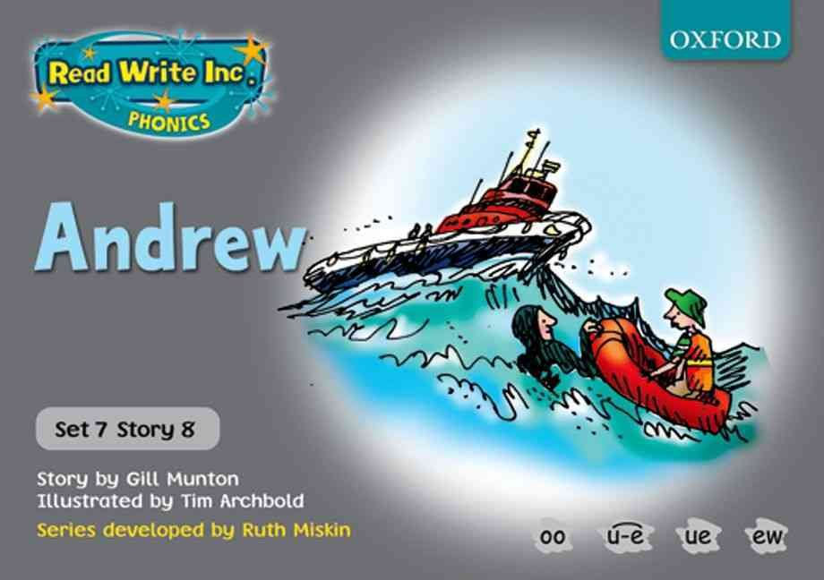  L.O. To be able to predict what might happen from details stated and implied. | vPhonics - Watch the videos of Miss Fergus to complete your speed sounds and green words. Then complete your daily phonics activity. Today I would like you to write two lines of the ‘ure’ sound in your red book.  Front Cover - Have a look at the front cover and discuss your new book.  Clarify – Listen to Miss Fergus clarify the new words and their meaning.  Story Introduction – Listen to Miss Fergus read the story introduction.  Prediction  Our new book is called ‘Andrew’’  Andrew goes to the beach with his older brother, Stewart. While Stewarts sits on the sand dunes, reading his newspaper Andrew decides to try out his new blow-up boat. One minute he is bobbing about in the sea, listening to the gulls and the next minute he is in terrible trouble! Andrew has fallen asleep and drifted far out to sea…  What do you predict will happen? Will he be saved? If so, who will save him?  Write your prediction in your red book underneath the date and learning objective.
Miss Lonsdale | L.O. To be able to predict what might happen from details stated and implied.  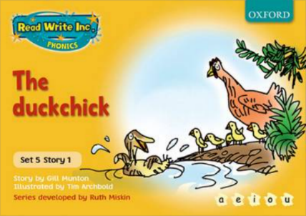 | Miss Fergus has recorded a video to explain your lesson for today.  Phonics - Watch the videos of Miss Lonsdale to complete your speed sounds and green words. Then complete your daily phonics activity. Today I would like you to write a sentence in your red book using at least two words containing the ‘kn’ sound.  Front Cover - Have a look at the front cover and discuss your new book.  Clarify – Listen to Miss Fergus clarify the new words and their meaning.  Story Introduction – Listen to Miss Fergus read the story introduction.  Prediction  Our new book is called ‘The duckchick’  On a sunny afternoon, Mama hen decides to take the chicks and the duckchick to the pond. They chicks are having fun pecking up delicious grubs from the mud and the duckchick is splashing around in the pond. They were all having so much fun that they did not realise that a fox was spying on them from the bushes…  What do you predict will happen?  Write your prediction in your red book underneath the date and learning objective.
Mrs Potter and Mrs Davidson | L.O - To read and discuss a text. | Prediction  Practice this week's spellings.  Read the next text.  Make a prediction.  Summarise the paragraphs.  Think of some questions.  Write down any words you need to look up and clarify.  Write your work in your red book underneath the date and learning objective.
English | LO: To use and understand SPaG terminology. | Listen to Mrs Davidson as she reads the first part of our new text - Romeo and Juliet.  There are a range of Spelling, Punctuation and Grammar activities in your 2Do’s on Purple Mash. Do as many as you like - you should aim to spend 30 minutes at least on this.  Remember to hand in your work and leave a comment letting us know how you got on.
Maths | L.O: To be able to interpret a pictogram. | Miss Burn has recorded a video walking you through your lesson. Click on the slides and follow Miss Burn as she explains what you are going to do today.  Practise your 8 times table by watching ‘Super Movers’ and playing ‘Top Marks Daily Ten’.  Today we are looking at interpreting a pictogram in order to be able to answer questions.  Task  Copy the date and learning objective into your YELLOW book.  Your task is to look carefully at the pictograms you have been given.  Answer the questions by interpreting what the pictograms show.  Please answer the questions in full sentences.
Geography | L.O: To be able to locate countries and cities in Europe. | This week you are going to have a geography lesson every day.  Today we are starting with a lesson all about the countries and cities in Europe.  We will be looking specifically at the countries and cities associated with the Titanic.  Task  Read the lesson slides.  Task 1  Your task is to locate England, France, Northern Ireland and the Republic of Ireland on a map of Europe. These are the countries that were significant in the journey of the Titanic. Can you colour in the countries on the map and then colour in the key to show the colours you used?  There were passengers on the Titanic from the following European countries:  Hungary Bulgaria, Denmark, Finland, Germany, Greece, Italy, Portugal, Russia, Spain, Ukraine, Turkey, Sweden and Switzerland  Can you choose 5 of these countries, locate and colour them on your map and add them to the key?  Task 2  Can you label the following places on your maps of France and the United Kingdom:  Paris, Cherbourg, London, Belfast, Cardiff, Dublin, Edinburgh, Queenstown, Southampton
PSHE | L.O: To be able to understand what it takes to be a good learner and how to approach learning with a positive attitude. | We are starting a new theme this half term in PSHE. This is ‘Good To Be Me’.  Today we are looking at what it takes to be a good learner. We will discuss what we think we are good at and the ways in which we like to learn. We will then move onto looking at the different things that we can do to make ourselves good learners.  Read the presentation and then complete the task.  Task  You are now experts in what makes a great learner!  However, you have just met a younger child who is struggling with their learning and needs your help.  Can you create a poster or leaflet explaining all the different ways they can become a great learner?  Do not forget to send us a photograph of what you have created. We might even display some around school when we return.

Daily Learning tasks – Tuesday 23.02.21
Subject | Learning objective | Activity
LIVE Thrive lessons will be delivered throughout the day. You will receive an email if your child has been invited to attend these sessions.
Miss Burn | Reading Day | Phonics - Watch the videos of Miss Burn and complete your speed sounds and green words. Then complete your daily phonics activity. Today is spelling day 1. Remember our new sound is ‘e’’ so each of the spellings contain this sound. Ask a grown up to read out loud the following words - he, me. Write the date in your RED book and then write your spellings underneath.  Front Cover - Remind yourself of our new book.  Green words- Practise reading the green words on the PowerPoint  Red words- Practise reading the red words on the PowerPoint.  Reading Day  Today I would like you to spend time reading our new book using the ‘Snow Reading Book’ slides.  Think about these things while reading… predict, clarify, question and summarise.
Miss Fergus | Reading Day | Phonics - Watch the videos of Miss Lonsdale to complete your speed sounds and green words. Then complete your daily phonics activity. Today I would like you to complete the four ‘ure’ spellings shown on the PowerPoint.  Front Cover - Remind yourself of the book you have been reading.  Clarify - Clarify the words on the slide and discuss their meaning  Green words - Practise reading the green words on the PowerPoint  Red words - Practise reading the red words on the PowerPoint.  Reading Day  Today I would like you to spend time reading our new book using the next slides. Think about these things while reading… predict, clarify, question and summarise.
Miss Lonsdale | Reading Day | Phonics - Watch the videos of Miss Lonsdale to complete your speed sounds and green words. Then complete your daily phonics activity. Today I would like you to write two lines of your ‘ie’ sound in your red book.  Front Cover - Remind yourself of the book you have been reading.  Clarify - Clarify the words on the slide and discuss their meaning  Green words - Practise reading the green words on the PowerPoint  Red words - Practise reading the red words on the PowerPoint.  Reading Day  We have finished reading orange Read Write Inc. books and are moving onto yellow books. The stories in yellow books are a lot longer than the stories in our orange books so Miss Fergus has recorded a video of herself reading your new book to you. She will read the story and clarify the unfamiliar words so that have a better understanding about the story before you read it  Today I would like you to spend time reading our new book using the next slides. Think about these things while reading… predict, clarify, question and summarise.
Mrs Potter and Mrs Davidson | L.O - To answer questions about a familiar text. | Reading day  Read the text again; check that you understand what all of the words mean.  Answer the questions about the text in your red book.  You can write the questions and then your answer OR you can write them out in a full sentence using the question in your answer, just as we do in the classroom.
English | LO: To conduct research about William Shakespeare. | Listen to Miss Fergus and she reads the next part of our new text.  Today we are learning about William Shakespeare.  Watch the video linked on the Year 3 website, taking notes. You might need to watch it more than once!  You should then create a fact file. Ensure to include basic information about William Shakespeare - his date of birth and date of death, where he lived, his family, what his job was and any other interesting information that you find! You can set out your fact file however you like.
Maths | L.O: To be able to collect data in order to create a tally chart and a pictogram. | Miss Burn has recorded a video walking you through your lesson. Click on the slides and follow Miss Burn as she explains what you are going to do today.  Practise your 8 times table by watching ‘Super Movers’ and playing ‘Top Marks Daily Ten’.  Today we are looking at collecting/creating our own data to create a tally chart and a pictogram.  Task  Copy the date and learning objective into your YELLOW book.  Your task is to collect data /or create your own data about anything of your choice.  This might be favourite food, hair colour, favourite animal, favourite TV show etc.  I would like you to show me this data in a tally chart and then create a pictogram of your data.  Remember to think carefully about your key and use a ruler when drawing your tables.  You must have at least 4 categories in your tally chart and pictogram.  Challenge: Can you think of three questions that you could ask about your pictogram?
Geography | L.O: To be able to locate countries, states and cities in North America. | Today we are going to be locating the countries, states and cities in North America.  Task  Read the lesson slides.  Task 1  Your task is to locate the United States of America on a map of North America. This was supposed to be the final destination of the Titanic.  Can you colour in the United States of America on the map and then colour in the key to show the colour you used?  There were lots of passengers on the Titanic from the USA. There were also passengers from Canada and Mexico.  Can you locate these 2 countries, colour them in on your map and add them to the key?  Task 2  Can you label the following places on your map of the United States of America?  California, Sacramento, Texas, Austin, Florida, Tallahassee, New York, Albany, Pennsylvania, Harrisburg, New York City
Art | L.O - To be able to discuss work of different artists. | Red through the lesson slides. Think about what a portrait is and how they are different for each of the artist's pictures. What do you notice about each of them?  Your task today is to draw a portrait - it can be of yourself, a family member or from a picture or photograph. Send us a picture of your portrait. We would love to see it.

Daily Learning tasks – Wednesday 24.02.21
Subject | Learning objective | Activity
Miss Burn | L.O. To be able to answer questions to check my understanding of a text. | Phonics - Watch the videos of Miss Burn and complete your speed sounds and green words. Then complete your daily phonics activity. Today is spelling day 2. Remember our new sound is “e’’ so each of the spellings contain this sound. Ask a grown up to read aloud the following words - be, we, she. Write the date in your RED book and then write your spellings underneath.  Front Cover - Remind yourself of the book you have been reading.  Green words- Practise reading the green words on the PowerPoint  Red words- Practise reading the red words on the PowerPoint.  Then read your book.  Comprehension  Write the learning objective underneath your spellings in your RED book and then answer the questions using the sentence structures in your lesson slides.
Miss Fergus | SPaG Activity | Phonics - Watch the videos of Fergus to complete your speed sounds and green words. Then complete your daily phonics activity. Today I would like you to write a sentence using at least 2 words that contain the ‘ure’ sound.  Front Cover - Remind yourself of the book you have been reading.  Clarify - Clarify the recently introduced words and their meaning  Green words - Practise reading the green words on the PowerPoint  Red words - Practise reading the red words on the PowerPoint.  Then read your book.  Today’s task  I would like you to complete the #improveit and #describeit writing activities shown on the PowerPoint. Please write in your red book underneath the date and learning objective.
Miss Lonsdale | L.O. To be able to identify verbs and adjectives within a text. | Phonics - Watch the videos of Miss Lonsdale to complete your speed sounds and green words. Then complete your daily phonics activity. Today I would like you to write the four ‘ie’ spellings that are  shown on the PowerPoint.  Front Cover - Remind yourself of the book you have been reading.  Clarify - Clarify the recently introduced words and their meaning  Green words - Practise reading the green words on the PowerPoint  Red words - Practise reading the red words on the PowerPoint.  Then read your book.  Today’s task  I would like you to write down all of the verbs and adjectives you can find in your storybook. Write them in your red book.  Verbs are doing or action words.  Adjectives are describing words.
Mrs Potter and Mrs Davidson | L.O - To be able to retrieve and record information. | Today you are going to be a cryptozoologist  Read through the lesson slides  You are going to do some research and find out about animals that people think might exist, but they do not have any proof they exist.  Look at the 3 creatures you have been given - research and find out 5 facts for each of them.  Write your findings in your red book; make sure it is set out neatly.
Maths | L.O: To be able to construct a bar chart. | Miss Burn has recorded a video walking you through your lesson. Click on the slides and follow Miss Burn as she explains what you are going to do today.  Practise your 8 times table by watching ‘Super Movers’ and playing ‘Top Marks Daily Ten’.  Today we are looking at constructing a bar chart using a tally chart or pictogram.  Task  Copy the date and learning objective into your YELLOW book.  For today's task, you need the pictogram that you drew yesterday. I would like you to use this pictogram to create a bar chart. Please remember to draw your chart with a pencil and a ruler.  A good bar chart needs to include:  - A title  - A suitable scale  - Categories along the bottom  - Neatly drawn and coloured in bars to represent each category.
Kahoot! | LIVE LESSON - Kahoot Quiz  Join Miss Fergus and your friends in another live lesson on kahoot! We learnt a lot about Christianity so far this year so let us see how much you can remember!  Keep an eye on your emails for the zoom link. You can type in kahoot on the internet or click on the link to play on a laptop, tablet or IPAD or you can play using the kahoot app. You do not need a login to play. Please have a pen and paper ready so that you can write down the game pin.
Use this time to read your Accelerated Reader book and take your quiz on:
https://ukhosted61.renlearn.co.uk/2246069/
The login information is on the personal logins that you were sent.
Please note that some children in Miss Burn’s and Miss Lonsdale’s Read Write Inc. groups will not have access to this. Please use this time to read some books
at home or listen to some stories here: https://www.bbc.co.uk/bitesize/topics/zx339j6/resources/1 (Or type in BBC Bitesize Fiction Stories into Google)
Geography | L.O: To be able to compare the human and physical geography of Southampton, Cherbourg and New York City. | Today we are looking at the similarities and differences in the human and physical geography of Southampton, Cherbourg and New York City.  Read the lesson slides.  Task  Using the worksheet and the information in the slides, your task today is to fill in the 4 sections of the table:  Section 1 - Similarities in the human geography of Southampton, Cherbourg and New York City.  Section 2 - Differences in the human geography of Southampton, Cherbourg and New York City.  Section 3 - Similarities in the physical geography of Southampton, Cherbourg and New York City.  Section 4 - Differences in the physical geography of Southampton, Cherbourg and New York City.
Science | LO: To identify and compare everyday materials. | Mrs Davidson has filmed this lesson for you. Watch the video through, or read through the lesson slides and then complete your task in your red book. Remember to use a ruler (or something hard with a straight edge!) to keep your work neat and tidy.  You are coming up with your own designs for some essential household items!

Daily Learning tasks – Thursday 25.02.21
Subject | Learning objective | Activity
Miss Burn | L.O. To be able to use verbs in my writing. | Phonics - Watch the videos of Miss Burn and complete your speed sounds and green words. Then complete your daily phonics activity. Today is the first day of our new sound - ‘ue.’ I would like you to write the date in your RED book and then practise your handwriting by writing 2 lines of your new sound ‘ue’.  Front Cover - Remind yourself of the book you have been reading.  Green words- Practise reading the green words on the PowerPoint  Red words- Practise reading the red words on the PowerPoint.  Then read your book.  Big Write  For today's big write, I would like you to describe what you might see if you looked out your window and saw it had been snowing. Write the learning objective underneath your new sound in your RED book and then complete your big write using the sentence structures provided in your lesson slides.  When I look out of my window, I can see _________________________ .  The children are _________________________.  The snow is _______________________.  I can also see _________________ and ________________.
Miss Fergus | L.O. To be able to answer questions to check my understanding of a text. | Phonics - Watch the videos of Miss Fergus to complete your speed sounds and green words. Then complete your daily phonics activity. Today I would like you to write two lines of the ‘oo’ sound in your red book.  Front Cover - Remind yourself of the book you have been reading.  Clarify - Clarify the recently introduced words and their meaning  Green words - Practise reading the green words on the PowerPoint  Red words - Practise reading the red words on the PowerPoint.  Then, read your reading book.  Comprehension  Write the date and the learning objective in your red book and complete your comprehension questions underneath.
Miss Lonsdale | L.O. To be able to answer questions to check my understanding of a text. | Phonics - Watch the videos of Miss Lonsdale to complete your speed sounds and green words. Then complete your daily phonics activity. Today I would like you to write a sentence using at least two words containing your ‘ie’ sound.  Front Cover - Remind yourself of the book you have been reading.  Clarify - Clarify the recently introduced words and their meaning  Green words - Practise reading the green words on the PowerPoint  Red words - Practise reading the red words on the PowerPoint.  Then, read your reading book.  Comprehension  Write the date and the learning objective in your red book and complete your comprehension questions underneath.
Mrs Potter and Mrs Davidson | L.O - To plan writing by recording ideas. | Last day to practice your spellings.  Today you are going to create your own creature - you need to draw a picture and make notes about it around the outside of the picture.  Read the lesson slides and look at the ideas to help you.  What does it look like?  What is its character like?  What does it do? How does it move around?
Maths | L.O: To be able to interpret a bar chart to answer questions. | Miss Burn has recorded a video walking you through your lesson. Click on the slides and follow Miss Burn as she explains what you are going to do today.  Practise your 8 times table by watching ‘Super Movers’ and playing ‘Top Marks Daily Ten’.  Today we are looking at interpreting a pictogram in order to be able to answer questions.  Task  Copy the date and learning objective into your YELLOW book.  Your task is to look carefully at the bar charts you have been given.  Answer the questions by interpreting what the bar charts show.  Please answer the questions in full sentences.
English | LO: To write a playscript. | Watch the video and listen to Mrs Potter read the next section of our story.  For this lesson, you need to read through the play script I have given as an example. Come up with some ideas about what could happen next.  Choose one of your ideas and continue to write the next section of the play script. Although we haven’t looked at play scripts before, hopefully you can use the example playscript to help you with how to set your work out.  This is a cold write (although I have given you a bit of help by giving you the first part of the play script!).
Geography | L.O: To be able to understand the significance of longitude and latitude. | Today we are looking at the significance of latitude and longitude lines.  Read the lesson slides.  Task  Look at the map on your worksheet.  It shows the latitude and longitude of significant places throughout the Maiden voyage of the Titanic.  Using longitude and latitude would have been a great way for the Carpathia to find the Titanic during its rescue.  Can you match the location to the correct longitude and latitude coordinates on your sheet using the map to help you?
RE | L.O: To be able to explain what we already know about Palm Sunday. | This half term in RE we are going to be continuing to learn about Christianity. We will be specifically looking at the question ‘What do Christians remember on Palm Sunday?’  Task  Your task today is to copy the date and learning objective into you RED book and then in the middle of your page write the question 'What do you already know about Palm Sunday, Lent and Easter'. Around this, I would like you to fill your page with anything you already know about Palm Sunday, Lent and Easter.  Then read the next slide and watch the videos on our website. Can you write 3 new things you have learnt about Palm Sunday in your book?

Daily Learning tasks – Friday 26.02.21
Subject | Learning objective | Activity
Miss Burn | L.O. To be able to predict what might happen  From details stated and implied.  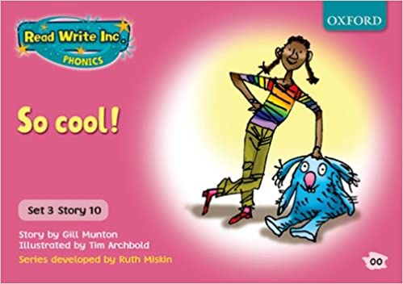 | Phonics - Watch the videos of Miss Burn and complete your speed sounds and green words. Then complete your daily phonics activity. Today is spelling day 1. Remember our new sound is ‘ue’’ so each of the spellings contain this sound. Ask a grown up to read aloud the following words - cue, blue, rescue. Write the date in your RED book and then write your spellings underneath.  Prediction  Today we are starting a new book. Our new book is called ‘So cool!’  Day 1 of a new book is prediction day.  Have a look at the front cover. Does this give you any clues about the book?  Have a look at this week’s words to clarify.  Read the book introduction.  Then make your prediction :  “When I grow up, I’ll have a flat with everything I want,” Annie tells them grumpily. “It will be so cool!”  What do you predict Annie will want in her new house?  Write the learning objective into your RED book and make your prediction using the sentence  starter:  I predict that Annie will want a _____________, a _____________ and _______________________ in her new house.
Miss Fergus | L.O. To be able to write a fictional narrative about a personal narrative using past tense verbs. | Miss Fergus has recorded a video to explain your lesson for today.  Phonics - Watch the videos of Miss Fergus to complete your speed sounds and green words. Then complete your daily phonics activity. Today I would like you to complete the four ‘oo’ spellings shown on the powerpoint.  Front Cover - Remind yourself of the book you have been reading.  Clarify - Clarify the recently introduced words and their meaning  Green words - Practise reading the green words on the PowerPoint  Red words - Practise reading the red words on the PowerPoint.  Then, read your reading book.  Big Write - Diary Entry  Write the date and the learning objective in your red book  Today, I would like you to write a diary entry in the first person from Andrew’s perspective about his day at the beach and the terrible incident that occurred.
Miss Lonsdale | L.O. To be able to identify new vocabulary within a text. | Miss Fergus has recorded a video to explain your lesson for today.  Phonics - Watch the videos of Miss Lonsdale to complete your speed sounds and green words. Then complete your daily phonics activity. Today I would like you to write two lines of your ‘au’ sound in your red book.  Front Cover - Remind yourself of the book you have been reading.  Clarify - Clarify the recently introduced words and their meaning  Green words - Practise reading the green words on the PowerPoint  Red words - Practise reading the red words on the PowerPoint.  Then, read your reading book.  Clarify  Write the date and the learning objective in your red book and then write a sentence for each of the words on the PowerPoint slide and explain their meaning
Mrs Potter and Mrs Davidson | L.O - to compose sentences orally and then write them down. | Spelling test - get an adult to read out the spellings -how did you do?  Read the lesson slide and watch the video.  Today you are going to write a character description for the creature you created yesterday.  Use all of the ideas you have been given to help you.
ICT | L.O: To be able to think about different methods of communication. | This half term in ICT, we are going to be using 2Email in Purple Mash.  Today we are looking at different methods of communication. Read the lesson presentation.  Task  You are going to create a mind map of methods of communication as well as the advantages and disadvantages of these methods.  Log in to Purple Mash and look for the 2Do:  - 2DO: Methods of Communication  Complete the mind map using the lesson presentation to help you, then save, and hand in the mind map when you are finished.
English | LO: To act out a play script. | Mrs Davidson is teaching this lesson LIVE. Join in at 11am following the link in your emails.  Today you will be showing off your dramatic side!
Geography | L.O: To be able to indicate and describe climate zones using a map. | Today we are going to be identifying and describing 3 climate zones on a world map.  Read the lesson slides.  Task  Your task is to create a climate zone map on your worksheet. You need to colour the areas of the map the correct colour, colour in the key and label the North Pole, South Pole, Atlantic Ocean and Equator.  Then, on the back of your worksheet, fill in the missing words and complete the table.  Challenge  Can you explain how there was an iceberg in the Atlantic Ocean when it generally has a mild climate?
Purple Mash | Log in to Purple Mash and enjoy some free time!

