Spring 2 Week 1 Home Learning Tasks
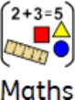  Monday - fractions of amounts  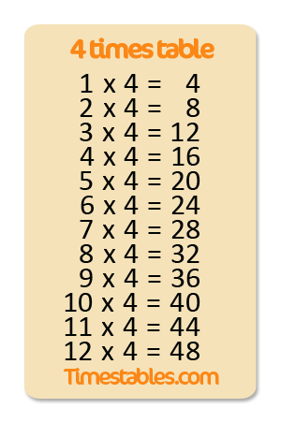  Tuesday - rounding  Wednesday - angles in a quadrilateral  Thursday - mixed numbers to improper fractions and calculations  practice your 4 times tables at the start of every maths lesson you do.  See if you can time yourself and get faster at saying them every day. | Science  In this lesson, we will be learning about living things and their habitats. We are recapping on our knowledge from year 4 and looking at animal groups.  Create a mindmap for each animal group with their features. | Monday - Predict what you think our new class text will be about. Can you use clues from the front cover to ask and answer questions about the story? Watch Mrs Blakey read Chapter 1.  Tuesday - Cold write - Write an informal letter to a loved one who has been sent to fight in World War 1.  Wednesday - What was life like in the trenches? Clarify new vocabulary and think of adjectives to describe the picture of the soldiers in the trench.  Thursday - Grammar starter - prepositions. Describe a World War 1 scene using descriptive language and prepositions.  Friday - Reading comprehension - read about World War 1 and answer the questions.  Spellings Sir link a lot:  Group 1 Group 2  receive meet and meat  rhythm pair and pair  temperature paw, poor and pour  thorough  vehicle
MUSIC  https://classroom.thenational.academy/lessons/developing-body-percussion-part-2-6cw6cr  In this lesson, we will be improving our body percussion skills even further. | 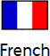  brain warm up - numbers 20-40 and school subjects  This half term we will be looking at what is in a French town. use the word mat to help you match the pictures to the sentences.  Challenge: translate the sentences from French to English. | This half term we will be studying the work of World War 1 artist William Orpen. Find out about his early life and career on the Western Front and evaluate some of his most popular paintings.
Monday - Spell your name using the fitness alphabet sheet. First and last name!  Thursday - Use a dice to roll the fitness monopoly. play against someone else in your family. Who can get all the way around the board first? | History  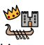  We will start our learning about World War 1 by finding out how it began and what were the main causes.  Which countries were involved and why? Log on to Google classroom to complete the map of Europe to show who were the Allies and who were the Central Powers. | Using the images on the powerpoint to write how each of those images link to the Christian Easter Story

