REMOTE LEARNING 2020/21 – Year 3 Week 5

The timetable below is provided to ensure that your child can continue to access learning whilst absent from school. Your child’s teacher will provide the learning to be completed in the allocated slots on the timetable. If your child is unwell there is no expectation that they complete the activities on this timetable but would do what they can when you feel they are well enough. These continue to be unprecedented times and we must work together to ensure that children's learning continues to progress. As during lockdown, teachers will remain in touch and will respond to any queries you may have. This timetable and accompanied learning is not meant to burden you at home but to provide clarity of what your child is expected to do when unable to access school. Thank you for your support, keep following us on Twitter and together we will continue to make this work.

 | 9.00 - 9.30 | 9.30 - 10.30 | 10.30-11.30 | 11.30 - 12.30 | 12.30-1.30 | 1.30 - 2.30 | 2.30-3.30
Monday | RWI – Phonics/  Reading | English | 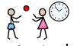  Break Time | 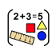  Maths | Dinner Time | 1.00 PM - LIVE History(Mrs Potter) | PSHE
Tuesday | RWI – Phonics/  Reading | Maths | Break Time | English | Dinner Time | Art/DT | PE
Wednesday | RWI – Phonics/  Reading | Maths | Break Time | 11.30 LIVE LESSON Kahoot (Miss Fergus) | Dinner Time | Science | French
Thursday | RWI – Phonics/  Reading | Maths | Break Time | English | Dinner Time | RE | DoodleMaths
Friday | RWI – Phonics/ Reading | DoodleMaths | Break Time | English | Dinner Time | Music | Purple Mash
Daily Learning tasks – Monday 01.02.21

Subject | Learning objective | Activity
Miss Burn | L.O. To be able to answer questions to check my understanding of a text.  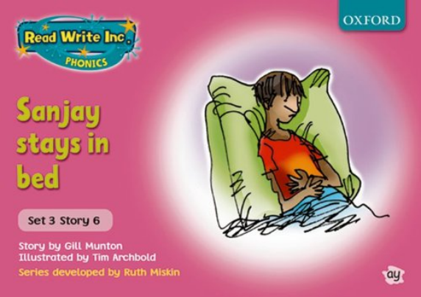 | Phonics - Watch the videos of Miss Burn and complete your speed sounds and green words. Then complete your daily phonics activity. Today is spelling day 1. Remember our new sound is ‘oa’ so each of the spellings contain this sound. Ask a grown up to read out loud the following words - goat, boat, toast. Write the date in your RED book and then write your spellings underneath.  Front Cover - Remind yourself of the book you have been reading.  Green words - Practise reading the green words on the PowerPoint  Red words - Practise reading the red words on the PowerPoint.  Then read your book.  Comprehension  Write the learning objective underneath your spellings in your RED book and then answer the questions using the sentence structures in your lesson slides.
Miss Fergus | 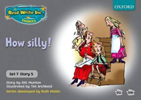  L.O. To be able to answer questions to check my understanding of a text. | Phonics - Watch the videos of Miss Fergus and complete your speed sounds and green words. Then complete your daily phonics activity. Today I would like you to write a sentence in your red book using at least two words containing the ‘ue’ sound.  Front Cover - Remind yourself of the book you have been reading.  Clarify - Clarify the recently introduced words and their meaning  Green words - Practise reading the green words on the PowerPoint  Red words - Practise reading the red words on the PowerPoint.  Then read your book.  Comprehension  Write the date and the learning objective at the top of your page and then answer the questions in your red book.
Miss Lonsdale | L.O. To be able to predict what might happen from details stated and implied.  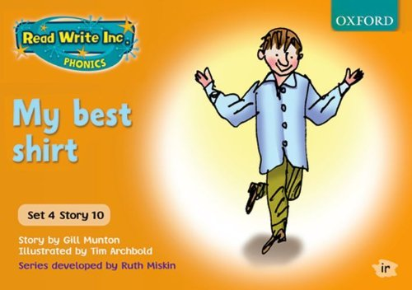 | Phonics - Watch the videos of Miss Lonsdale to complete your speed sounds and green words. Then complete your daily phonics activity. Today I would like you to write the four ‘ew’ spellings that are shown on the  powerpoint.  Front Cover - Have a look at the front cover and discuss your new book.  Prediction  Our new book is called ‘My best shirt’.  Tom is having a birthday party and things are going great until something terrible happens…  What do you predict happened?
Mrs Potter and Mrs Davidson | L.O - To read and discuss a text. | Practice your spellings in your book. Write them down and write a sentence for each one.  Read through the text, then in your book complete a prediction, summary, questions and any words you need clarifying, following the instructions in the lesson slides.
English | LO: To understand the features of a diary. | Watch the video of Mrs Davidson taking you through the lesson.  There is a video to watch on the BBC website about Homophones which is linked on the website. Feel free to do the activity and quiz as well.  Write today’s date and learning objective in your red book.  Your task today is to re-order the diary entry so that it is in the right order. Use the letters down the side to help you eg: 1 = F 2 = C and so on.
Maths | L.O: To be able to convert money between pounds and pence. | Miss Burn has recorded a video walking you through your lesson. Click on the slides and follow Miss Burn as she explains what you are going to do today.  Practise your 3 times table by watching ‘Super Movers’ and playing ‘Top Marks Daily Ten’.  Watch the video of Miss Burn talking through today's maths lesson.  Today we are looking at converting money between pounds and pence by understanding that 100p is the same as £1.  Task  Please copy the date and learning objective into your YELLOW book.  Task 1 - You have been given amounts of money in pence. Can you convert them to pounds and pence?  Example - 123p is the same as £1 and 23p  Task 2 - You have been given amounts of money. Can you work out how much money there is altogether and write your answer in pounds and pence?  £____ and ______p
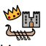  History/ Geography | L.O - To ask and answer questions about the past using historical data. | Watch the videos about the Titanic.  One is facts about the titanic  One is about the Titanic survivors  One is an interview of a Titanic survivor.  Now read through the lesson - Look at the graph and table of data. Answer the questions and discuss what you find with an adult.
PSHE | L.O: To be able to consider how expressing ourselves can support our mental health and explore ways in which we can do this. | This week is Children's Mental Health Week 2021.  This year the theme is 'Express Yourself'.  People express themselves in many different ways. We can express our personalities and individuality through art, drama, dance, role play, sport and music. That is what makes us unique. It makes you, you and me, me.  For today's task, we would like you to think about how you would describe yourself, how you like to express yourself and why you are proud to be you.  We would like you to create a poster. Draw yourself in the middle of the page and draw pictures and write words around it to tell us all about you and the ways you like to express yourself.  Please send us photographs of your poster so we can display them in our PSHE books in school.

Daily Learning tasks – Tuesday 02.02.21
Subject | Learning objective | Activity
LIVE Thrive lessons will be delivered throuhout the day. You will receive an email if your
Miss Burn | L.O. To be able to write simple sentences using taught sounds. | Phonics - Watch the videos of Miss Burn and complete your speed sounds and green words. Then complete your daily phonics activity. Today is spelling day 2. Remember our new sound is ‘oa’ so each of the spellings contain this sound. Ask a grown up to read out loud the following words - road, coat, throat. Write the date in your RED book and then write your spellings underneath.  Front Cover - Remind yourself of the book you have been reading.  Green words - Practise reading the green words on the PowerPoint  Red words - Practise reading the red words on the PowerPoint.  Then read your book.  Big Write  For today's big write, I would like you to describe where the gremlin is hiding in each of the pictures, on the lesson slides, by using prepositions. Write the learning objective underneath your spellings in your RED book and then complete your big write using the sentence structures provided in your lesson slides.
Miss Fergus | L.O. To be able to identify main ideas drawn from more than 1 paragraph and summarising these. | Miss Fergus has recorded a video walking you through your lesson. Click on the slides and follow Miss Fergus as she explains what you are going to do today.  Phonics - Watch the videos of Miss Fergus and complete your speed sounds and green words. Then complete your daily phonics activity. Today I would like you to practise your handwriting by writing 2 lines of your new sound ‘ph’ in your red book.  Front Cover - Remind yourself of the book you have been reading.  Clarify - Clarify the recently introduced words and their meaning  Green words - Practise reading the green words on the PowerPoint  Red words - Practise reading the red words on the PowerPoint.  Then read your book.  Big Write  Today, we will write a summary. A summary is a short,detailed explanation of a book. It gives the reader a good idea about what a text may be about without having read the book.  Today I would like you to complete the following:  Have you ever read…?  The characters are…  The story is set...  Please write today’s date and learning objective in your red book before you begin.
Miss Lonsdale | Reading Day | Phonics - Watch the videos of Miss Lonsdale to complete your speed sounds and green words. Then complete your daily phonics activity. Today I would like you to write a sentence using at least 2 words containing the ‘ew’ sound.  Front Cover - Remind yourself of the book you have been reading.  Story Introduction - Read the story introduction to learn more about our book.  Clarify - Clarify the words on the slide and discuss their meaning  Green words - Practise reading the green words on the PowerPoint  Red words - Practise reading the red words on the PowerPoint.  Reading Day  Today I would like you to spend time reading our new book using the next slides. Think about these things while reading… predict, clarify, question and summarise.
Mrs Potter and Mrs Davidson | L.O - To answer questions about a familiar text. | It’s question day!  Use the questions included with the text and answer them in full sentences in your book. Remember that if the question starts with a question word, you will need to change it when writing down your answer.
English | LO: To plan a diary entry. | Watch the video of Mrs Davidson taking you through the lesson.  There is an activity to complete on the BBC website for your brain warm up. The site is linked on the website.  Your task today is to plan a diary entry as if you were a first class child passenger on board the Titanic. You should complete this on a separate piece of paper so that it is handy when we come to write this later in the week. Use the template as a guide - remember this is a plan! You can write bullet points or draw pictures but there is no need for full sentences.
Maths | L.O: To be able to add two amounts of money together. | Miss Burn has recorded a video walking you through your lesson. Click on the slides and follow Miss Burn as she explains what you are going to do today.  Practise your 3 times table by watching ‘Super Movers’ and playing ‘Top Marks Daily Ten’.  Watch the video of Miss Burn talking through today's maths lesson.  Today we are looking at adding 2 amounts of money together by adding the pounds together first and then adding the pence together.  Task  Please copy the date and learning objective into your YELLOW book.  For your task on the lesson slides, you have pictures of items and children who want to buy them. Can you add together the amounts to work out how much they spend altogether?  Set it out like this example...  £3 and 50 pence + £2 and 60 pence = ___________________  £3 + £2 = £5  50p + 60p = £1 and 10 pence  Amir spends £6 and 10 pence altogether.
Art/ DT | L.O - To follow instructions during the making process. | Read through the lesson.  The main focus is following instructions.  Today in DT I would like you to make a cake, however it doesn’t have to be a cake, as due to lockdown it can be tricky to get out and get what you need. It can be anything, as long as you follow the instruction process and show me a photo of the end product.
PE | L.O - To develop footwork patterns. | Watch the video  Today I would like you to work on your footwork. This is important in all aspects of every day, but particularly important in sport.  In sport you need to be able to side step, dodge people and objects and get away from the opponent.  Send us a video of you completing this activity.

Daily Learning tasks – Wednesday 03.02.21
Subject | Learning objective | Activity
Miss Burn | L.O. To be able to predict what might happen from details stated and implied.  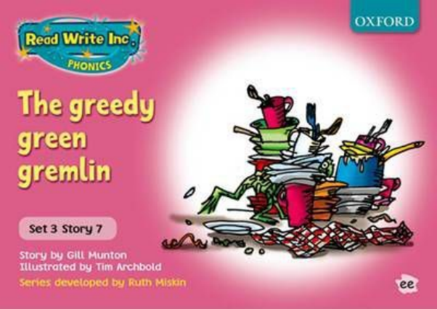 | Phonics - Watch the videos of Miss Burn and complete your speed sounds and green words. Then complete your daily phonics activity. Today is the first day of our new sound - ‘ew.’ I would like you to write the date in your RED book and then practise your handwriting by writing 2 lines of your new sound ‘ew’.  Prediction  Today is a prediction day.  Have a look at the front cover. Does this give you any clues about the book?  Have a look at this week’s words to clarify.  Read through the book introduction.  Then make your prediction :  After feasting on all the scraps, the gremlin sleeps in the dishcloth. When he’s bored, he plays catch with the plug. And at night, he keeps his teeth in a cracked coffee mug.  Where do you predict the gremlin is hiding?  Write the learning objective into your RED book and make your prediction using the sentence  starter - I predict that the gremlin is hiding...
Miss Fergus | L.O. To be able to identify main ideas drawn from more than 1 paragraph and summarising these. | Miss Fergus has recorded a video walking you through your lesson. Click on the slides and follow Miss Fergus as she explains what you are going to do today.  Phonics - Watch the videos of Miss Fergus to complete your speed sounds and green words. Then complete your daily phonics activity. Today I would like you to write the four ‘ph’ spellings that are  shown on the powerpoint.  Front Cover - Remind yourself of the book you have been reading.  Clarify - Clarify the recently introduced words and their meaning  Green words - Practise reading the green words on the PowerPoint  Red words - Practise reading the red words on the PowerPoint.  Then read your book.  Big Write - Continue writing your summary from yesterday.  Today I would like you to complete the following:  In the beginning...  In the middle...  In the end...
Miss Lonsdale | L.O. To be able to answer questions to check my understanding of a text. | Phonics - Watch the videos of Miss Lonsdale to complete your speed sounds and green words. Then complete your daily phonics activity. Today I would like you to write 2 lines of your new ‘e’ sound in your red book.  Front Cover - Remind yourself of the book you have been reading.  Clarify - Clarify the recently introduced words and their meaning  Green words - Practise reading the green words on the PowerPoint  Red words - Practise reading the red words on the PowerPoint.  Then, read through your reading book.  Comprehension  Write the date and the learning objective at the top of your page and then answer the questions in your red book.
Mrs Potter and Mrs Davidson | L.O - To identify word families | I have included a video recording of this lesson.  Watch the video and pause when you need to. Complete the activities about synonyms, replacing them, matching them and thinking of new ones.
Maths | L.O: To be able to subtract money. | Miss Burn has recorded a video walking you through your lesson. Click on the slides and follow Miss Burn as she explains what you are going to do today.  Practise your 3 times table by watching ‘Super Movers’ and playing ‘Top Marks Daily Ten’.  Watch the video of Miss Burn talking through today's maths lesson.  Today we are looking at subtracting money both using a part whole model and a number line.  Task  Please copy the date and learning objective into your YELLOW book.  For your task on the lesson slides, have a go at subtracting using both a part whole model and a number line.  For the part whole model questions I would like you to write out the 3 number sentences as below:  £5 - £2 = £3  50p - 10p = 40p  £5 and 50p - £2 and 10p = £3 and 40p  For the number line questions please draw the number line and show me the jumps you have made as well as writing a number sentence to show what you have worked out:  £5 - £3 and 65p = £1 and 35p
Kahoot! | LIVE LESSON - Kahoot Quiz  Join Miss Fergus and your friends in a live lesson as you take on a Titanic Quiz. Who will come out on top?  A link will be sent out to your email before the lesson begins. We will all join each other on a zoom call as you are shown how to access kahoot and stay on zoom at the same time! This will be the first time we have tried to play a game of kahoot remotely, so If you could stay with your child as we set them up we would really appreciate it! This is a lovely way for the children to have some fun alongside their friends. We always have so much fun playing this in school and we hope that it will be a great success so that we can continue to do this over the next few weeks! Thank you for your support!
Use this time to read your Accelerated Reader book and take your quiz on:
https://ukhosted61.renlearn.co.uk/2246069/
The login information is on the personal logins that you were sent.
Please note that some children in Miss Burn’s and Miss Lonsdale’s Read Write Inc groups will not have access to this. Please use this time to read some books
at home or listen to some stories here: https://www.bbc.co.uk/bitesize/topics/zx339j6/resources/1 (Or type in BBC Bitesize Fiction Stories into Google)
Science | LO: To understand that magnets can act at a distance. | Watch the video of Mrs Davidson taking you through the lesson.  Today you will use the resources in the brown envelope that your grown up has collected from school for you this week. You will also need colouring pens or pencils and scissors. We have attached the magnet to the string for you because they are a little smaller than expected!  We are making a magnet game! Watch the video carefully and pause when you need to.  Remember to send in your pictures of your magnet game.  PLEASE TAKE EXTRA CARE IF YOU HAVE YOUNG CHILDREN AT HOME AS THE MAGNETS ARE VERY SMALL!
French | L.O. To be able to say where I live and to be able to ask others where they live. | Warm up - Practise your French alphabet and numbers to 12.  Read through the powerpoint.  Speaking and Listening - Today we are continuing to look at the phrase ‘J'habite à…’ which means ‘I live in…’ We are also looking at how to ask somebody ‘Where do you live?’ which is ‘Où habites-tu?’. Can you practise these 2 phrases?  Main activity - Can you say the names of the French cities. Now can you pretend you live in each of these cities and say…  J'habite à _______. Example: J'habite à Paris.  What would we say if we are talking about where somebody else lives? We use the phrases; Elle habite à…. (She lives in…) or Il habite à… (He lives in…) depending on whether it is a boy or a girl.  Task  Write the date and learning objective in your red book.  Using the map on the lesson slides, I would like you to write for each child their name and where they live in France. Your sentences will be.. Elle/Il s'appelle __________. Elle/Il habite à ______________.  Examples: Elle s'appelle Amelie. Il s'appelle Gabriel.  Elle habite à Lyon. Il habite à Calais.
Daily Learning tasks – Thursday 04.02.21
Subject | Learning objective | Activity
Miss Burn | Reading Day | Phonics - Watch the videos of Miss Burn and complete your speed sounds and green words. Then complete your daily phonics activity. Today is spelling day 1. Remember our new sound is ‘ew’ so each of the spellings contain this sound. Ask a grown up to read out loud the following words - new, drew, blew. Write the date in your RED book and then write your spellings underneath.  Front Cover - Remind yourself of our new book.  Green words - Practise reading the green words on the PowerPoint  Red words - Practise reading the red words on the PowerPoint.  Reading Day  Today I would like you to spend time reading our new book using ‘The greedy green gremlin’ slides. Think about these things while reading… predict, clarify, question and summarise.
Miss Fergus | 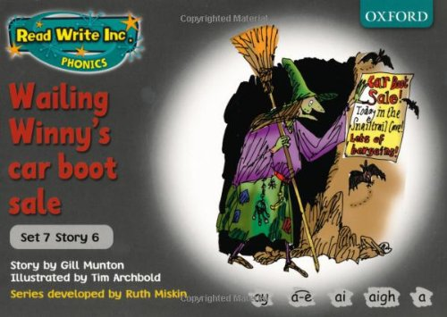  L.O. To be able to predict what might happen from details stated and implied. | Miss Fergus has recorded a video walking you through your lesson.. Click on the slides and follow Miss Fergus as she explains what you are going to do today.  Phonics - Watch the videos of Miss Fergus to complete your speed sounds and green words. Then complete your daily phonics activity. Today I would like you to write a sentence using at least 2 words containing the ‘ph’ sound.  Front Cover - Have a look at the front cover and discuss your new book.  Prediction  Wailing WInny is having a car boot sale. She is selling some very unusual things.  What do you predict Winny is selling?
Miss Lonsdale | L.O. To be able to write a fictional narrative using past tense verbs. | Miss Fergus has recorded a video walking you through your lesson. Click on the slides and follow Miss Fergus as she explains what you are going to do today.  Phonics - Watch the videos of Miss Lonsdale to complete your speed sounds and green words. Then complete your daily phonics activity. Today I would like you to write the four ‘e’ spellings that are shown on the powerpoint.  Front Cover - Remind yourself of the book you have been reading.  Clarify - Clarify the recently introduced words and their meaning  Green words - Practise reading the green words on the PowerPoint  Red words - Practise reading the red words on the PowerPoint.  Then, read through your reading book.  Big Write  Today, I would like you to write a diary entry from Tom’s perspective talking about his birthday.  Miss Fergus has recorded a lesson walkthrough for you. Click on the slides and follow Miss Fergus as she explains what you are going to do today.
Mrs Potter and Mrs Davidson | L.O - To identity the main ideas of a paragraph. | Read through the lesson slides.  Read the tory again, today you are going to choose your favourite scene from the story and draw a picture of it. Make sure that you pick up on small details and add them to your picture.  Send me a picture and see if I can guess which scene you have chosen.
Maths | L.O: To be able to subtract money to give change. | Miss Burn has recorded a video walking you through your lesson. Click on the slides and follow Miss Burn as she explains what you are going to do today.  Practise your 3 times table by watching ‘Super Movers’ and playing ‘Top Marks Daily Ten’.  Watch the video of Miss Burn talking through today's maths lesson.  Today we are looking at subtracting money to give change using a number line.  Task  Please copy the date and learning objective into your YELLOW book.  For your task on the lesson slides, I would like you to use a number line to work out how much change you would get from £5, £10 or £20 if you spent the amounts of money shown .  For each question I would like you to draw a number line to show the jumps you have made and then beside it write '£_____ and ______p change' to show me the answer.
English | LO: To write a diary entry. | Watch the video of Mrs Davidson taking you through the lesson.  There is an activity to complete on the BBC website for your brain warm up. The site is linked on the website.  Write today’s date and learning objective in your red book.  Your task today is to write a diary entry using your plan to help you. You should write your diary in your red book. You are writing the start up until the end of paragraph 2. I have included an example plan on the website if you are stuck. I show you how to use your plan to help you write on the video!
RE | L.O: To be able to write a prayer as a way of showing worship. | For today’s RE lesson we will be looking at examples of Christian prayers and songs that have been written as a way of saying thank you to God.  Read through the slides and watch the video.  Can you write a list of things that you are thankful for?  Task  Copy the date and learning objective into your RED book.  Using your list of ideas of what you are thankful for, I would like you to write your own thank you prayer or song.  You can use the structure provided on the lesson slide to help you write your prayer if you  would like to or you can choose your own way of writing it.
DoodleMaths | Log in to Doodle Maths and complete your daily questions. Then, enjoy some free time on Doodle Maths and Doodle Tables.

Daily Learning tasks – Friday 05.01.21
Subject | Learning objective | Activity
Miss Burn | L.O. To be able to answer questions to check my understanding of a text. | Phonics - Watch the videos of Miss Burn and complete your speed sounds and green words. Then complete your daily phonics activity. Today is spelling day 2. Remember our new sound is ‘ew’ so each of the spellings contain this sound. Ask a grown up to read out loud the following words - chew, flew, grew. Write the date in your RED book and then write your spellings underneath.  Front Cover - Remind yourself of the book you have been reading.  Green words - Practise reading the green words on the PowerPoint  Red words - Practise reading the red words on the PowerPoint.  Then read your book.  Comprehension  Write the learning objective underneath your spellings in your RED book and then answer the questions using the sentence structures in your lesson slides.
Miss Fergus | Reading day | Phonics - Watch the videos of Miss Fergus to complete your speed sounds and green words. Then complete your daily phonics activity. Today I would like you to write a sentence using 2 words that contain the ‘ph’ sound. You can write this in your red book.  Front Cover - Remind yourself of the book you have been reading.  Clarify - Clarify the words on the slide and discuss their meaning  Green words - Practise reading the green words on the PowerPoint  Red words - Practise reading the red words on the PowerPoint.  Reading Day  Today I would like you to spend time reading our new book using the next slides. Think about these things while reading… predict, clarify, question and summarise.
Miss Lonsdale | L.O. To be able to predict what might happen from details stated and implied.  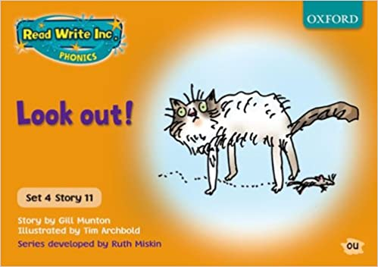 | Phonics - Watch the videos of Miss Fergus to complete your speed sounds and green words. Then complete your daily phonics activity. Today I would like you to write a sentence using 2 words that contain the ‘e’ sound. You can write this in your red book.  Front Cover - Have a look at the front cover and discuss your new book.  Prediction  Do you know someone who has ever had a mouse in their house - not a pet mouse but a wild mouse? One day, the family in this story find a mouse as it runs around their house…  What do you predict the mouse will do and where do you predict it will go?  Follow the slides and use the words provided to help you complete your prediction.
Mrs Potter and Mrs Davidson | L.O - To be able to create a setting. | Watch the video and follow the instructions.  Look at the list of words provided that will help you to write what happens when Ryan takes his first flight on Nightfire. Think about where you will be going, what you will see, feel and hear on your journey.
DoodleMaths | Log in to Doodle Maths and complete your daily questions. Then, enjoy some free time on Doodle Maths and Doodle Tables.
English | LO: To write a diary entry. | Watch the video of Mrs Davidson taking you through the lesson.  There is an activity to complete on the BBC website for your brain warm up. The site is linked on the website.  Write today’s date and learning objective in your red book.  Your task today is to finish writing your diary entry using your plan to help you. You should write your diary in your red book. I have included an example plan on the website if you are stuck.
Music | LO: To improvise and compose music. | Follow the lesson slides and recap your learning from last week.  Today you are improvising piano melodies on Garageband or online piano which is linked on the website.  Try to make a melody using only blues notes! I would love to see what you come up with :)
Purple Mash | Log in to Purple Mash and enjoy some free time!

